34.65: a) 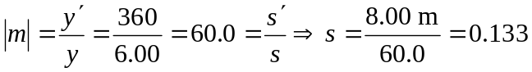 m is where the filament should be placed.
b) 